1U 16PON Port Pizza-Box EPON OLT
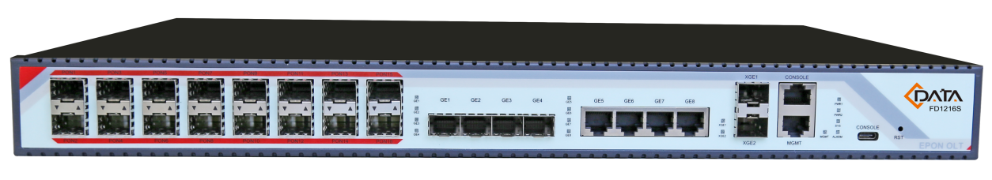
Pizza-Box OLT series products is 1U high 19 inch rack mount product. The features of the OLT are small, convenient, flexible, easy to deploy, high performance. It is appropriate to deploy in an compact room environment.
The OLT can use for “Triple-Play”, CPN, IP Camera, Enterprise LAN and IOT applications. It is a high performance products.
FD1216S-R1 provides 1 USB interface, 4GE(copper) and 4GE optical interface, 2*10Gb uplink interface, and 16 EPON ports for downstream. It can support 1024 ONUs under 1:64 splitter ratio.

Specifications
Item |  | FD1216S-R1
Chassis | Rack | 1U 19 inch standard box
Uplink Port | QTY | 10
Uplink Port | Copper | 10/100/1000M auto-negotiable,RJ45:4pcs
Uplink Port | Optical interface | 4 GE
Uplink Port | 10Gb uplink interface | 2*10Gb
PON Port | QTY | 16
PON Port | Physical Interface | SFP Slots
PON Port | Connector Type | 1000BASE-PX20+
PON Port | Max splitting ratio | 1:64
USB Port | QTY | 1
USB Port | Connector Type | TYPE-C
Management Ports |  | 1*100BASE－TX outband port; 1CONSOLE port
PON Port Specification  （Apply to  C-Data PON module） | Transmission Distance | 20KM
PON Port Specification  （Apply to  C-Data PON module） | PON port speed | Symmetrical 1.25Gbps
PON Port Specification  （Apply to  C-Data PON module） | Wavelength | 1490nm TX,1310nm RX
PON Port Specification  （Apply to  C-Data PON module） | Connector | SC/PC
PON Port Specification  （Apply to  C-Data PON module） | Fiber Type | 9/125μm SMF
PON Port Specification  （Apply to  C-Data PON module） | TX Power | +2.5～+7dBm
PON Port Specification  （Apply to  C-Data PON module） | Rx Sensitivity | -27dBm
PON Port Specification  （Apply to  C-Data PON module） | Saturation Optical Power | -6dBm
10Gb SFP+ Port Specification  （Apply to C-Data 10Gb module） | Transmission Distance | 10KM
10Gb SFP+ Port Specification  （Apply to C-Data 10Gb module） | PON port speed | 8.5-10.51875Gbps
10Gb SFP+ Port Specification  （Apply to C-Data 10Gb module） | Wavelength | 1310nmTX，1310nmRX
10Gb SFP+ Port Specification  （Apply to C-Data 10Gb module） | Connector | LC
10Gb SFP+ Port Specification  （Apply to C-Data 10Gb module） | Fiber Type | Single mode with dual fiber
10Gb SFP+ Port Specification  （Apply to C-Data 10Gb module） | TX Power | -8.2~+0.5 dBm
10Gb SFP+ Port Specification  （Apply to C-Data 10Gb module） | Rx Sensitivity | -12.6dBm
Management Mode |  | SNMP, Telnet, CLI management mode.
Management Function |  | Fan Group Detecting  Port Status monitoring and configuration management;  Layer-2 switch configuration such as Vlan, Trunk ,RSTP,IGMP ,QOS, etc;  EPON management function: DBA ,ONU authorization, ACL ,QOS ,etc;  Online ONU configuration and management  User management  Alarm management
Layer-two Switch |  | Support port VLan and protocol Vlan  Support Vlan tag/Untag ,vlan transparent transmission;  Support 4096 VLAN  Support 802.3dd trunk  RSTP  QOS based on port ,VID,TOS and MAC address  IGMP Snooping  802.x flow control  Port stability statistic and monitoring
EPON Function |  | Support port-based rate limitation and bandwidth control;  In compliant with IEEE802.3ah Standard  Up to 20KM transmission Distance  Support data encryption, group broadcasting, port Vlan separation, RSTP, etc.  Support Dynamic Bandwidth Allocation (DBA)  Support ONU auto-discovery/Link detection/remote upgrade of software;  Support VLAN division and user separation to avoid broadcast storm;  Support various LLID configuration and single LLID configuration .Different user and different service could provide different QoS by means of different LLID channels.  Support power-off alarm function ,easy for link problem detection  Support broadcasting storm resistance function  Support port isolation between different ports  Support ACL and SNMP to configure data packet filter flexibly  Specialized design for system breakdown prevention to maintain stable system  Support dynamic distance calculation on EMS online  Support RSTP,IGMP Proxy
Layer-three Route |  | Support static unicast  Support static multicast  Support RIP routing protocol  Support dynamic multicast protocol with active source
Backplane Bandwidth |  | 88G
Dimension |  | 440*350*44(mm*mm*mm）
Weight |  | 6kg
Power Supply | 220VAC | AC: 90V～240V，47/63Hz
Power Supply | -48DC | DC:-36V～-72V
Power Consumption |  | 70W
Operating Environment | Working Temperature | 0～50℃
Operating Environment | Storage Temperature | -40～85℃
Operating Environment | Relative Humidity | 5～90%(non-condensing)

